QUESTION 1

View the Exhibit and examine the structure of ORDERS and CUSTOMERS tables.

There is only one customer with the cust_last_name column having value Roberts. Which INSERT statement should be used to add a row into the ORDERS table for the customer whose CUST_LAST_NAME is Roberts and CREDIT_LIMIT is 600?

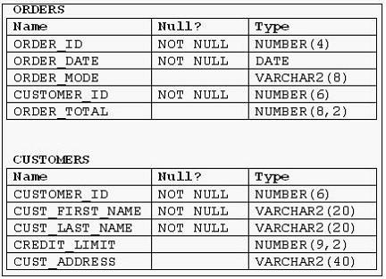

A. | INSERT INTO orders  VALUES (1,'10-mar-2007', 'direct',  (SELECT customer_id  FROM customers  WHERE cust_last_name='Roberts' AND  credit_limit=600), 1000);
B. | INSERT INTO orders (order_id,order_date,order_mode,  (SELECT customer_id  FROM customers  WHERE cust_last_name='Roberts' AND  credit_limit=600),order_total)  VALUES(1,'10-mar-2007', 'direct', &&customer_id, 1000);
C. | INSERT INTO(SELECT o.order_id, o.order_date,o.order_mode,c.customer_id, o.order_total  FROM orders o, customers c  WHERE o.customer_id = c.customer_id  AND c.cust_last_name='Roberts' ANDc.credit_limit=600 )  VALUES (1,'10-mar-2007', 'direct',(SELECT customer_id  FROM customers  WHERE cust_last_name='Roberts' AND  credit_limit=600), 1000);
D. | INSERT INTO orders (order_id,order_date,order_mode,  (SELECT customer_id  FROM customers  WHERE cust_last_name='Roberts' AND  credit_limit=600),order_total)  VALUES(1,'10-mar-2007', 'direct', &customer_id, 1000);

QUESTION 2
Evaluate the following command:

CREATE TABLE employees
(employee_id NUMBER(2) PRIMARY KEY,
last_name VARCHAR2(25) NOT NULL,
department_id NUMBER(2)NOT NULL,
job_id VARCHAR2(8),
salary NUMBER(10,2));

You issue the following command to create a view that displays the IDs and last names of the sales staff in the organization:

CREATE OR REPLACE VIEW sales_staff_vu AS
SELECT employee_id,
last_name,job_id
FROM employees
WHERE job_id LIKE 'SA_%' WITH CHECK OPTION;

Which two statements are true regarding the above view? (Choose two.)

A. | It allows you to insert rows into the EMPLOYEES table.
B. | It allows you to delete details of the existing sales staff from the EMPLOYEES table.
C. | It allows you to update job IDs of the existing sales staff to any other job ID in the EMPLOYEES table.
D. | It allows you to insert IDs, last names, and job IDs of the sales staff from the view if it is used in multitable  INSERT statements.

QUESTION 3
View the Exhibit and examine the structure of the SALES, CUSTOMERS, PRODUCTS, and TIMES tables.

The PROD_ID column is the foreign key in the SALES table, which references the PRODUCTS table. Similarly, the CUST_ID and TIME_ID columns are also foreign keys in the SALES table referencing the CUSTOMERS and TIMES tables, respectively.

Evaluate the following CREATE TABLE command:

CREATE TABLE new_sales(prod_id, cust_id, order_date DEFAULT SYSDATE) AS
SELECT prod_id, cust_id, time_id
FROM sales;

Which statement is true regarding the above command?

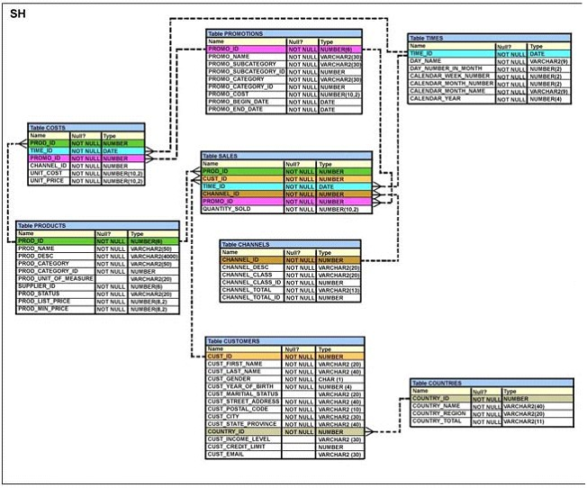

A. | The NEW_SALES table would not get created because the DEFAULT value cannot be specified  in the column definition.
B. | The NEW_SALES table would get created and all the NOT NULL constraints defined  on the specified columns would be passed to the new table.
C. | The NEW_SALES table would not get created because the column names  in the CREATE TABLE command and the SELECT clause do not match.
D. | The NEW_SALES table would get created and all the FOREIGN KEY constraints defined  on the specified columns would be passed to the new table.

QUESTION 4

View the Exhibit and examine the structure of the CUSTOMERS table.

Evaluate the following SQL statement:

SQL> SELECT cust_city, COUNT(cust_last_name)
FROM customers
WHERE cust_credit_limit > 1000
GROUP BY cust_city
HAVING AVG(cust_credit_limit) BETWEEN 5000 AND 6000;

Which statement is true regarding the outcome of the above query?

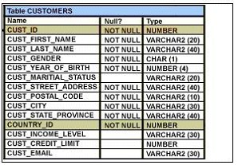

A. | It executes successfully.
B. | It returns an error because the BETWEEN operator cannot be used in the HAVING clause.
C. | It returns an error because WHERE and HAVING clauses cannot be used in the same SELECT statement.
D. | It returns an error because WHERE and HAVING clauses cannot be used to apply conditions on the same column.

QUESTION 5

View the Exhibit and examine the structure of the PROMOTIONS table.

Using the PROMOTIONS table, you need to find out the average cost for all promos in the ranges $0-2000 and $2000-5000 in category A.

You issue the following SQL statement:

SQL>SELECT AVG(CASE

WHEN promo_cost BETWEEN 0 AND 2000 AND promo_category='A'
THEN promo_cost
ELSE null END) "CAT_2000A",
AVG(CASE
WHEN promo_cost BETWEEN 2001 AND 5000 AND promo_category='A' THEN promo_cost
ELSE null END) "CAT_5000A"
FROM promotions;

What would be the outcome?

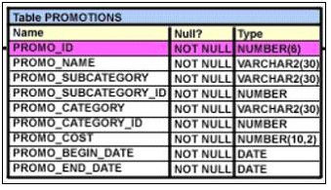

A. | It executes successfully and gives the required result.
B. | It generates an error because NULL cannot be specified as a return value.
C. | It generates an error because CASE cannot be used with group functions.
D. | It generates an error because multiple conditions cannot be specified for the WHEN clause.

QUESTION 6
Evaluate the following query:

SQL> SELECT promo_name || q'{'s start date was }' || promo_begin_date AS "Promotion Launches"
FROM promotions;

What would be the outcome of the above query?

A. | It produces an error because flower braces have been used.
B. | It produces an error because the data types are not matching.
C. | It executes successfully and introduces an 's at the end of each promo_name in the output.
D. | It executes successfully and displays the literal " {'s start date was } " for each row in the output.

QUESTION 7
Evaluate the following query:

SELECT INTERVAL '300' MONTH,
INTERVAL '54-2' YEAR TO MONTH,
INTERVAL '11:12:10.1234567' HOUR TO SECOND
FROM dual;

What is the correct output of the above query?

A. | +25-00 , +54-02, +00 11:12:10.123457
B. | +00-300, +54-02, +00 11:12:10.123457
C. | +25-00 , +00-650, +00 11:12:10.123457
D. | +00-300 , +00-650, +00 11:12:10.123457

QUESTION 8
You issued the following command to drop the PRODUCTS table:

SQL> DROP TABLE products;

What is the implication of this command? (Choose all that apply.)

A. | All data along with the table structure is deleted.
B. | The pending transaction in the session is committed.
C. | All indexes on the table will remain but they are invalidated.
D. | All views and synonyms will remain but they are invalidated.
E. | All data in the table are deleted but the table structure will remain.

QUESTION 9

View the Exhibit and examine the structure of the CUSTOMERS table.

NEW_CUSTOMERS is a new table with the columns CUST_ID, CUST_NAME and CUST_CITY that have the same data types and size as the corresponding columns in the CUSTOMERS table.

Evaluate the following INSERT statement:

INSERT INTO new_customers (cust_id, cust_name, cust_city)
VALUES(SELECT cust_id,cust_first_name||' '||cust_last_name,cust_city FROM customers
WHERE cust_id > 23004);

The INSERT statement fails when executed. What could be the reason?

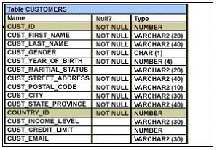

A. | The VALUES clause cannot be used in an INSERT with a subquery.
B. | Column names in the NEW_CUSTOMERS and CUSTOMERS tables do not match.
C. | The WHERE clause cannot be used in a subquery embedded in an INSERT statement.
D. | The total number of columns in the NEW_CUSTOMERS table does not match the total number of  columns in the CUSTOMERS table.

QUESTION 10

View the Exhibit and examine the structure of the PROMOTIONS table.

Using the PROMOTIONS table, you need to display the names of all promos done after January 1, 2001, starting with the latest promo.

Which query would give the required result? (Choose all that apply.)

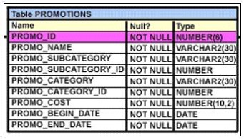

A. | SELECT promo_name, promo_begin_date  FROM promotions  WHERE promo_begin_date > '01-JAN-01'  ORDER BY 2 DESC;
B. | SELECT promo_name, promo_begin_date  FROM promotions  WHERE promo_begin_date > '01-JAN-01'  ORDER BY promo_name DESC;
C. | SELECT promo_name, promo_begin_date  FROM promotions  WHERE promo_begin_date > '01-JAN-01'  ORDER BY 1 DESC;
D. | SELECT promo_name, promo_begin_date "START DATE"  FROM promotions  WHERE promo_begin_date > '01-JAN-01'  ORDER BY "START DATE" DESC;

QUESTION 11
Evaluate the following SQL commands:

SQL>CREATE SEQUENCE ord_seq
INCREMENT BY 10
START WITH 120
MAXVALUE 9999
NOCYCLE;

SQL>CREATE TABLE ord_items
(ord_no NUMBER(4)DEFAULT ord_seq.NEXTVAL NOT NULL,

item_no NUMBER(3),
qty NUMBER(3) CHECK (qty BETWEEN 100 AND 200),
expiry_date date CHECK (expiry_date > SYSDATE),
CONSTRAINT it_pk PRIMARY KEY (ord_no,item_no),
CONSTRAINT ord_fk FOREIGN KEY(ord_no) REFERENCES orders(ord_no));

The command to create a table fails. Identify the reason for the SQL statement failure? (Choose all that apply.)

A. | You cannot use SYSDATE in the condition of a CHECK constraint.
B. | You cannot use the BETWEEN clause in the condition of a CHECK constraint.
C. | You cannot use the NEXTVAL sequence value as a DEFAULT value for a column.
D. | You cannot use ORD_NO and ITEM_NO columns as a composite primary key because ORD_NO is also  the FOREIGN KEY.

QUESTION 12

View the Exhibit and examine the structure and data in the INVOICE table.

Which two SQL statements would execute successfully? (Choose two.)

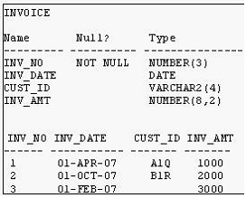

A. | SELECT AVG(inv_date)  FROM invoice;
B. | SELECT MAX(inv_date),MIN(cust_id)  FROM invoice;
C. | SELECT MAX(AVG(SYSDATE - inv_date))  FROM invoice;
D. | SELECT AVG( inv_date - SYSDATE), AVG(inv_amt)  FROM invoice;

QUESTION 13
Which arithmetic operations can be performed on a column by using a SQL function that is built into Oracle database? (Choose three.)

A. | addition
B. | subtraction
C. | raising to a power
D. | finding the quotient
E. | finding the lowest value

QUESTION 14

View the Exhibit and examine the structure of the SALES table.

The following query is written to retrieve all those product IDs from the SALES table that have more than 55000 sold and have been ordered more than 10 times.

SQL> SELECT prod_id
FROM sales
WHERE quantity_sold > 55000 AND COUNT(*)>10
GROUP BY prod_id HAVING COUNT(*)>10;

Which statement is true regarding this SQL statement?

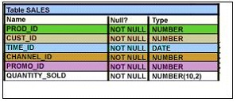

A. | It executes successfully and generates the required result.
B. | It produces an error because COUNT(*) should be specified in the SELECT clause also.
C. | It produces an error because COUNT(*) should be only in the HAVING clause and not in the WHERE clause.
D. | It executes successfully but produces no result because COUNT(prod_id) should be used instead of COUNT(*).

QUESTION 15
You need to create a table with the following column specifications:

1. Employee ID (numeric data type) for each employee
2. Employee Name (character data type) that stores the employee name
3. Hire date, which stores the date of joining the organization for each employee
4. Status (character data type), that contains the value 'ACTIVE' if no data is entered
5. Resume (character large object [CLOB] data type), which contains the resume submitted by the employee

Which is the correct syntax to create this table?

A. | CREATE TABLE EMP_1  (emp_id NUMBER(4),  emp_name VARCHAR2(25),  start_date DATE,  e_status VARCHAR2(10) DEFAULT 'ACTIVE',  resume CLOB(200));
B. | CREATE TABLE 1_EMP  (emp_id NUMBER(4),  emp_name VARCHAR2(25),  start_date DATE,  emp_status VARCHAR2(10) DEFAULT 'ACTIVE',  resume CLOB);
C. | CREATE TABLE EMP_1  (emp_id NUMBER(4),  emp_name VARCHAR2(25),  start_date DATE,  emp_status VARCHAR2(10) DEFAULT "ACTIVE",  resume CLOB);
D. | CREATE TABLE EMP_1  (emp_id NUMBER,  emp_name VARCHAR2(25),  start_date DATE,  emp_status VARCHAR2(10) DEFAULT 'ACTIVE',  resume CLOB);

